Jesus Nolazco

Chapter 9

**lastModified Property**

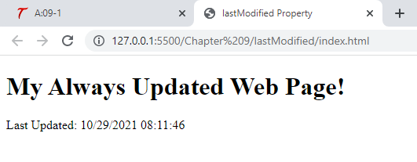

<!DOCTYPE html>

<html>

<head>

    <title>lastModified Property</title>

</head>

<body>

    <h1>My Always Updated Web Page!</h1>

    <script type="text/JavaScript">

        document.write("Last Updated: " + document.lastModified);

    </script>

</body>

</html>

**Title Property**

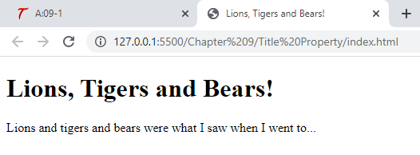

<!DOCTYPE html>

<html>

<head>

    <title>Lions, Tigers and Bears!</title>

</head>

<body>

    <script type="text/javascript">

        document.write("<h1>" + document.title + "</h1");

    </script>

    <p>Lions and tigers and bears were what I saw when I went to...</p>

</body>

</html>

**URL Property**

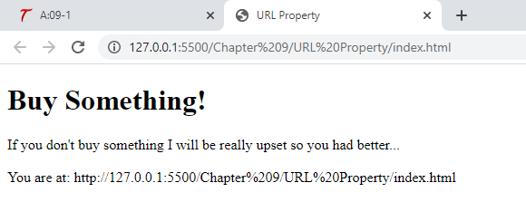

<!DOCTYPE html>

<html>

<head>

    <title>URL Property</title>

</head>

<body>

    <h1>Buy Something!</h1>

    If you don't buy something I will be really upset so you had better...

    <br><br>

    <script type="text/javascript">

        document.write("You are at: " + document.URL);

    </script>

</body>

</html>

**Page 236 Open() Close()**

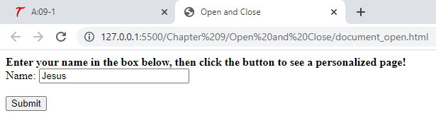

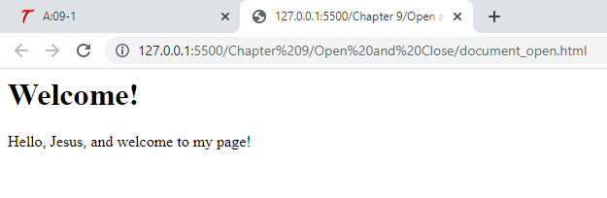

<!DOCTYPE html>

<html>

<head>

    <title>Open and Close</title>

</head>

<body>

    <strong>Enter your name in the box below, then click the button to see a personalized page!</strong>

    <br>

    <form id="newp" onsubmit="newpage();">

        Name: <input type="text" id="yourname" size="25">

        <br><br>

        <input type="submit" value="Submit">

    </form>

    <script type="text/javascript" src="document_open.js"></script>

</body>

</html>

function newpage() {

    let thename = document.getElementById("yourname").value;

    document.open();

    document.write("<h1>Welcome!</h1>");

    document.write("Hello, " + thename + ", and welcome to my page!");

    document.close();

}

**Page 238-241 Value of title attribute**

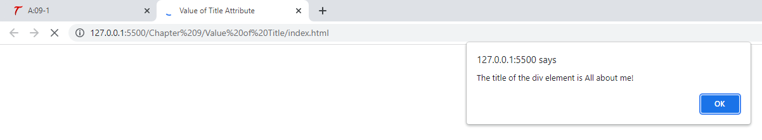

<!DOCTYPE html>

<html>

<head>

    <title>Value of Title Attribute</title>

</head>

<body>

    <div id="div1" title="All about me!">

        this page is about met, me, and.... me!

    </div>

    <script src="valuetitlejs.js"></script>

</body>

</html>

let me_div = document.getElementById("div1");

window.alert("The title of the div element is " + me_div.title);

**Page 241 – Page 244**

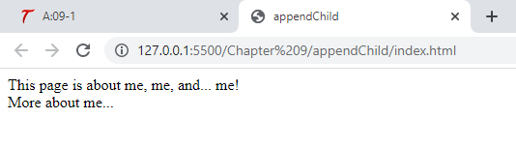

<!DOCTYPE html>

<html>

<head>

    <title>appendChild</title>

</head>

<body>

    <div id="div1" title="All about me!">

        This page is about me, me, and... me!

    </div>

    <script src="appendjs.js"></script>

</body>

</html>

let me_div = document.getElementById("div1");

let inner_div = document.createElement("div");

let inner_div_text = document.createTextNode("More about me...");

inner_div.appendChild(inner_div_text);

inner_div.title = "More";

me_div.appendChild(inner_div);

**Try This 9-1**

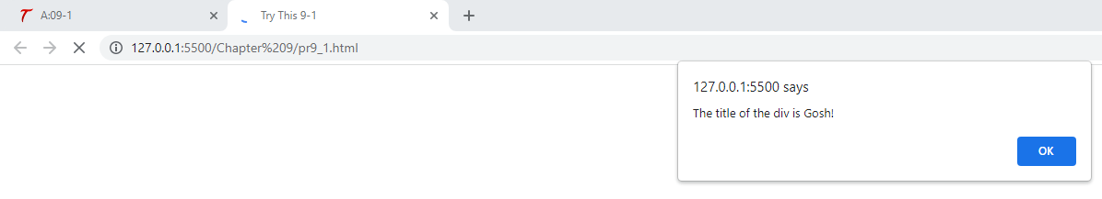

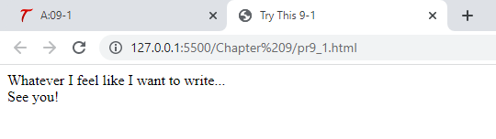

<!DOCTYPE html>

<html>

<head>

    <title>Try This 9-1</title>

</head>

<body>

    <div id="div1" title="Gosh!">

        Whatever I feel like I want to write...

    </div>

    <script type="text/javascript" src="prjs9_1.js"></script>

</body>

</html>

let me_div = document.getElementById("div1");

window.alert(me_div.title);

let new_div = document.createElement("div");

let new_div_text = document.createTextNode("See you!");

new_div.appendChild(new_div_text);

new_div.title = "Lucky!";

me_div.appendChild(new_div);

**Page 250-251 innerHTML**

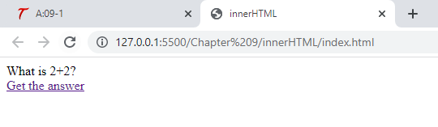

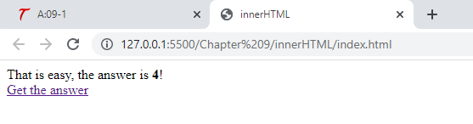

<!DOCTYPE html>

<html>

<head>

    <title>innerHTML</title>

</head>

<body>

    <div id="div1">

        What is 2+2?

    </div>

    <div id="div2">

        <a href="answer.html" id="answer_link">Get the answer</a>

    </div>

    <script type="text/javascript" src="innerjs.js"></script>

</body>

</html>

let d1 = document.getElementById("div1");

let answer_link = document.getElementById("answer_link");

answer_link.onclick = function() {

    d1.innerHTML = "That is easy, the answer is <strong>4</strong>!";

    return false;

};

**Try-This 9-2**

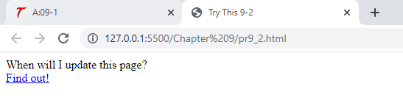

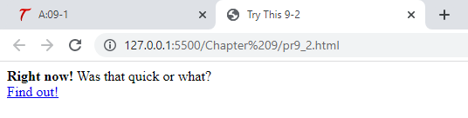

<!DOCTYPE html>

<html>

<head>

    <title>Try This 9-2</title>

</head>

<body>

    <div id="div1">

        When will I update this page?

    </div>

    <div id="div2">

        <a href="answer.html" id="c_link">Find out!</a>

    </div>

    <script src="prjs9_2.js"></script>

</body>

</html>

let d1 = document.getElementById("div1");

let c_link = document.getElementById("c_link");

c_link.onclick = function() {

    d1.innerHTML = "<strong>Right now!</strong> Was that quick or what?";

    return false;

};